**Module-2: GIT Assignment – 1**

1.Create a new folder.

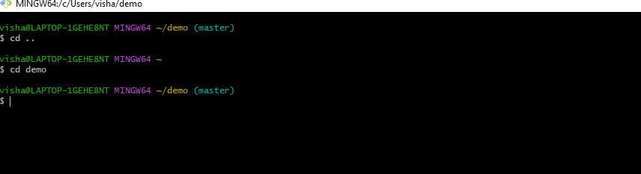

2.Put the following files in the folder

○ Code.txt

○ Log.txt

○ Output.txt

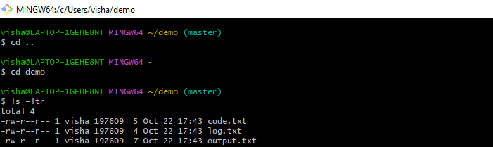

3. Stage the Code.txt and Output.txt files

4.Commit them.

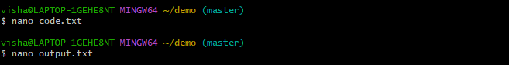

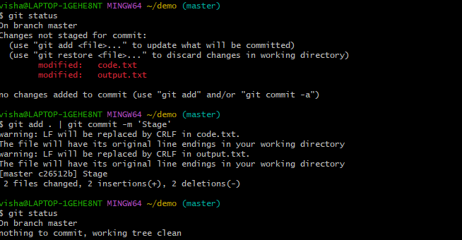

5.And finally push them to github.

